**CVE 80018: FINITE ELEMENT METHODS AND APPLICATIONS**

Assignment 1: Finite Element Analysis of Structures

By

**HAIDER ALI (104323332)**



Submitted to

Dr. Hendrik Wijaya

Master of Professional Engineering

SWINBURNE UNIVERSITY OF TECHNOLOGY, AUSTRALI

Table of Contents

**INTRODUCTION** 3

**Problem statement no.1:** 3

Solution 1: 3

Axial force: 4

SFD & BMD 5

Nodal Displacement 6

Conclusion: 7

**Problem Statement no.2:** 9

Solution no. 2: 9

Stresses in Element 11

**Problem Statement no.3:** 14

Solution no. 3 14

Table of Figures

Figure 1: Maximum Axial force in member as a rigid frame 4

Figure 2:Maximum Axial Force in member as a plane truss frame 4

Figure 3: Maximum SF & BM in member as a rigid frame 5

Figure 4: Maximum SF & BM in member as a plane truss 6

Figure 5: Maximum Displacement in node as a rigid frame 6

Figure 6:Maximum Displacement in node as a plane truss 7

Figure 7: Elongation in 1-D element Beam 10

Figure 8: Elongation in 2-D element Beam 10

Figure 9: Elongation in 5-D element Beam 11

Figure 10: Elongation in 10-D element Beam 11

Figure 11: Maximum Stresses in 1-D element 12

Figure 12: Maximum Stresses in 2-D element 12

Figure 13: Maximum Stresses in 5-D element 13

Figure 14: Maximum Stresses in 10-D element 13

Figure 15: Principle stresses in a Metal Plate with a circular cutout 15

Figure 16: Principle stresses in a Metal Plate with a Rectangular cutout 15

# **INTRODUCTION**

What is Strand7 & FEM? A robust finite element analysis (FEA) programme called Strand7 is utilised for structural analysis and simulation of challenging engineering issues. It is frequently employed in the disciplines of mechanical, civil, and aeronautical engineering. A wide range of features, such as sophisticated material models, nonlinear analytical capabilities, and dynamic analysis tools, are available through Strand7. Numerous different analysis scenarios, including static and dynamic analysis, thermal analysis, and fatigue analysis, can be handled by it.

The software's user-friendly interface and reliable meshing mechanism make it possible to build intricate models with precise geometries. Additionally, it contains an integrated scripting language that enables the automation of difficult analysis tasks.

# **Problem statement no.1:**

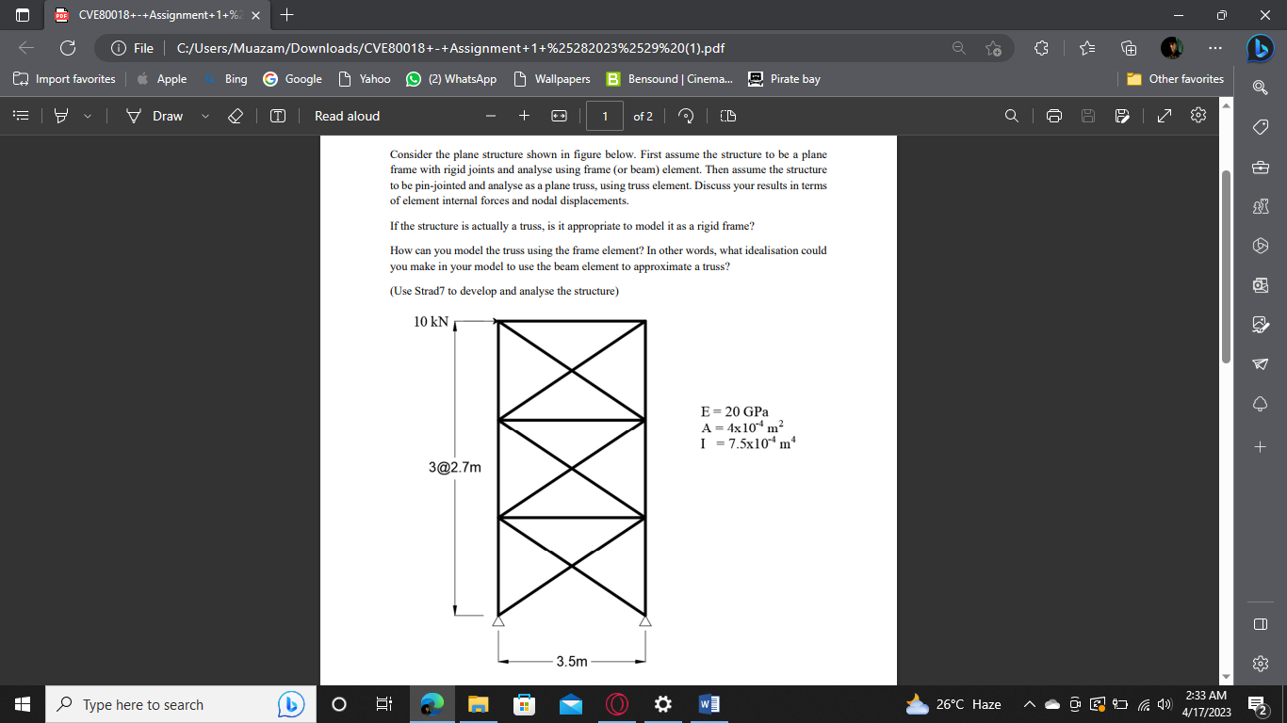**Consider the plane structure shown in figure below. First assume the structure to be a plane frame with rigid joints and analyse using frame (or beam) element. Then assume the structure to be pin-jointed and analyse as a plane truss, using truss element.**

**Discuss your results in terms of element internal forces and nodal displacements. If the structure is actually a truss, is it appropriate to model it as a rigid frame? How can you model the truss using the frame element? In other words, what idealisation could you make in your model to use the beam element to approximate a truss?**

## Solution 1:

An interconnected system of elements that are rigidly attached at their ends to form a closed network or frame is referred to as a planar frame with stiff joints. All of the members and joints of the frame are in the same plane since it is planar.

The connections between the members in a plane frame with stiff joints are made to be completely rigid, preventing any relative rotation or translation at the joints. This implies that the lengths of the members do not change with stress, and the angles between the members stay fixed.

The term "rigid" in this context alludes to the joints' idealistic behaviour, which is rarely reached in real-world systems because of deformations and other variables. Engineers can simplify calculations and obtain approximative yet helpful answers for the behaviour of the frame under different loads by assuming stiff joints in the analysis of a flat frame.

A plane truss structure is a kind of structural system made up of a number of connected components that are often shaped like triangles and are intended to resist external loads largely through axial forces (tension and compression), rather than bending. A truss structure has joints or nodes connecting the components at the ends, and the entire thing is flat.

A truss construction is made to transport weights uniformly among all of its parts, especially along its axial direction. In comparison to other structural forms like beams or frames, the structure is able to resist loads and distribute stresses more effectively as a result. The truss can be built with less material and at a lower cost by solely applying axial forces.

### 1.1 Axial force:

The internal force in the member which is produced in it due to tension or compression is known as Axial force.

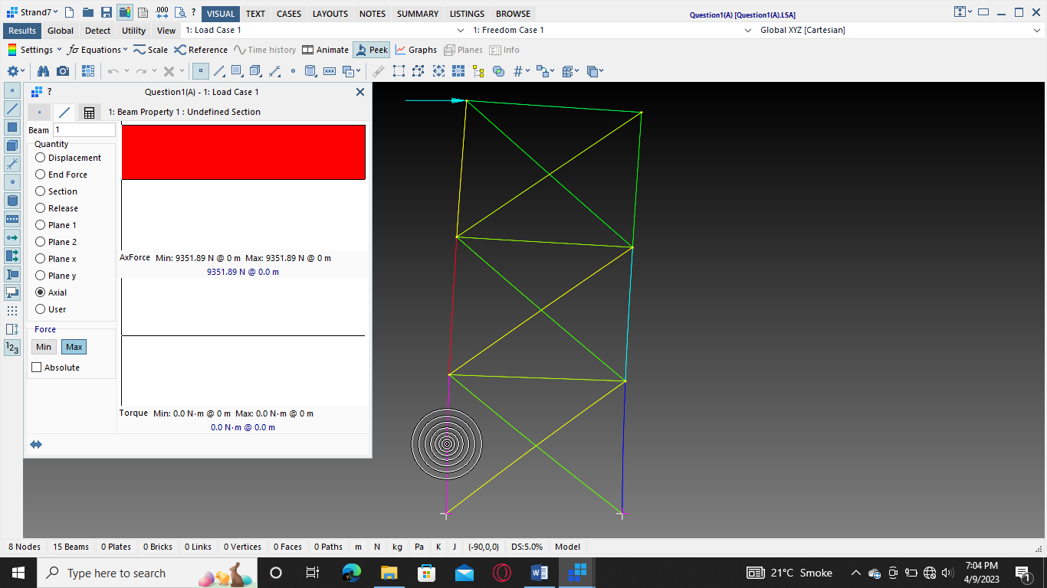Fig.1 shows the maximum Axial force (9.351 KN) in the member in the critical member, when we use rigid connection in beams. & Fig.2 show the axial force (10.36 KN) in member when we use beams as a truss member.

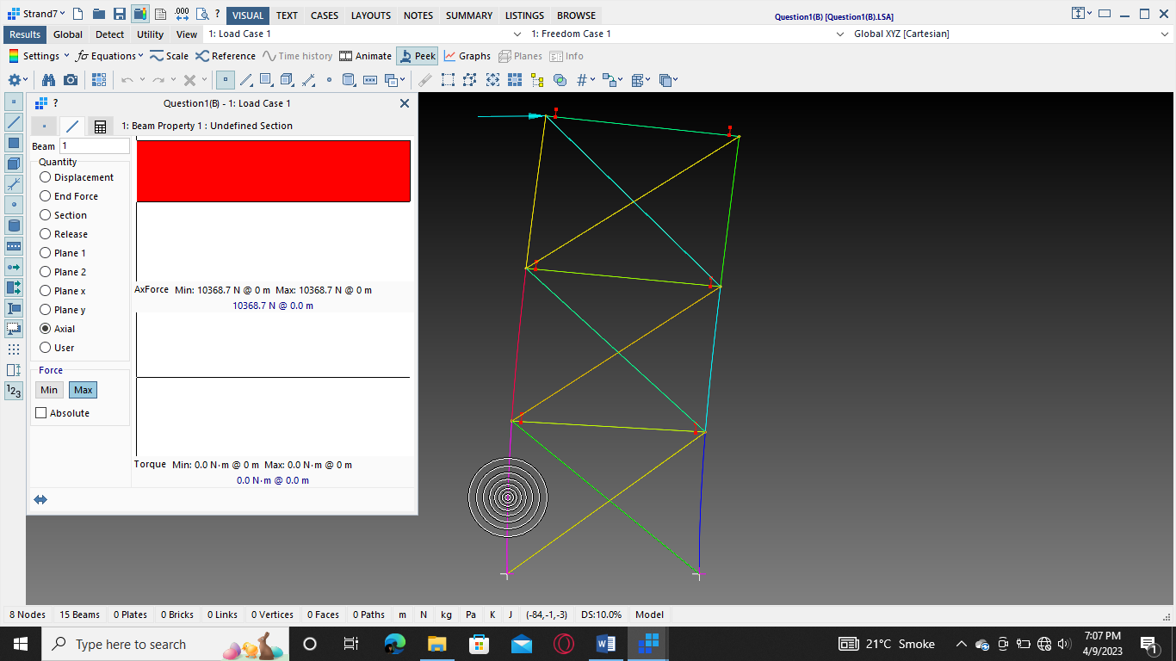Figure 1: Maximum Axial force in member as a rigid frame

Figure 2:Maximum Axial Force in member as a plane truss frame

The axial force in members of plane trusses is more than Rigid frame structure because, in contrast to truss structures, rigid frame structures use components that are designed to sustain loads largely through bending and shear stresses rather than axial forces (tension and compression). As a result, the axial force in a truss member is often greater than the bending stress in a matching component of a rigid frame for a given external load.

The reason for this is that truss members are long and narrow, allowing the external load to be transmitted down their length and produce an axial force. The members of a rigid frame, on the other hand, are often larger and built to withstand bending forces brought on by the external load.

### 1.2 SFD & BMD

The force acting parallel to the cross-section of the beam or other structural component is referred to as a shear force. It is brought on by loads that are applied perpendicular to the beam's longitudinal axis, and it usually results in the beam sliding or deforming in a shear way. Typically, the shear force is measured in units of force like newtons (N) or pounds-force (lbf).

Contrarily, a bending moment is a moment brought on by loads acting perpendicular to the longitudinal axis of a beam or other structural component. The beam is more likely to bend or deform in a bending fashion as a result of this moment. Typically, the bending moment is given in torque units like newton-meters (Nm) or pound-feet.

In a rigid frame, every member transfers its moment and shear force to the connected members, creating shear and moment in every member. However, in truss members, each member carries its own load and bears it independently, resulting in the absence of bending moment and shear force, leaving only axial forces. This is also the reason truss members have a higher axial force than rigid frame members. As depicted in Figures 3 and 4,

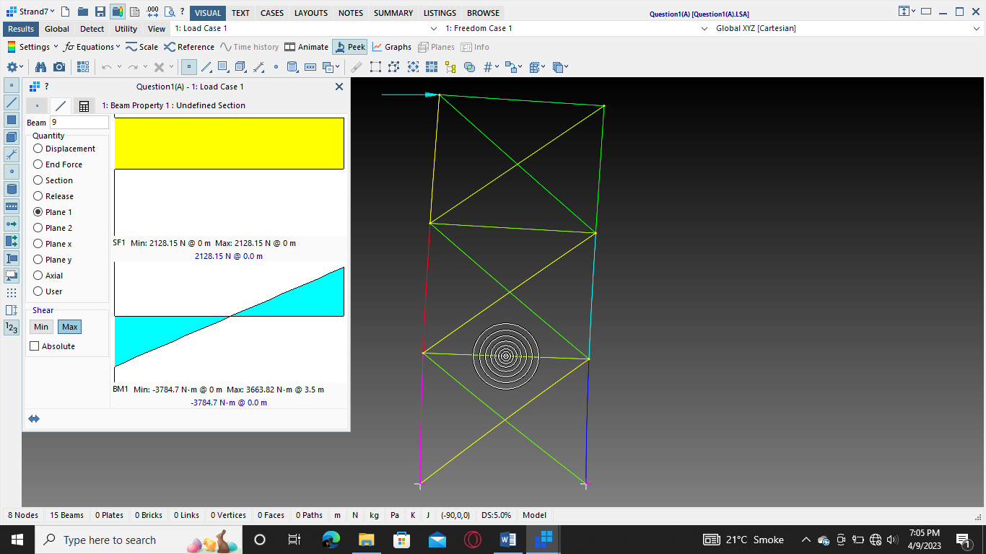

Figure 3: Maximum SF & BM in member as a rigid frame

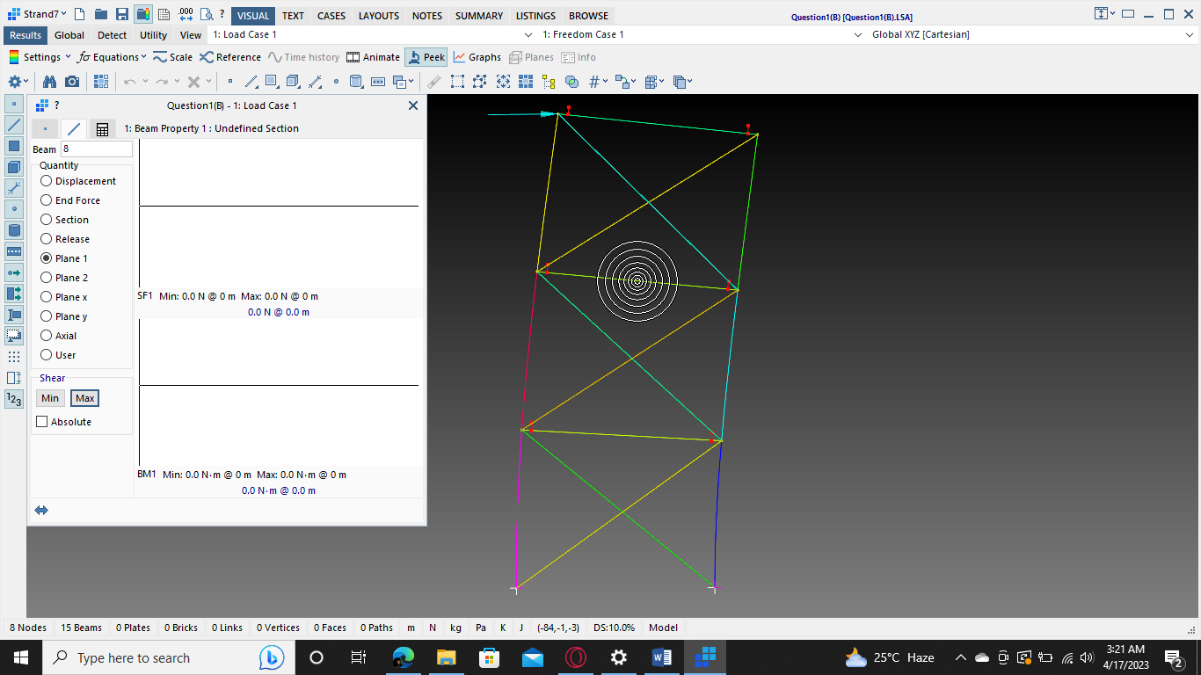

Figure 4: Maximum SF & BM in member as a plane truss

### 1.3 Nodal Displacement

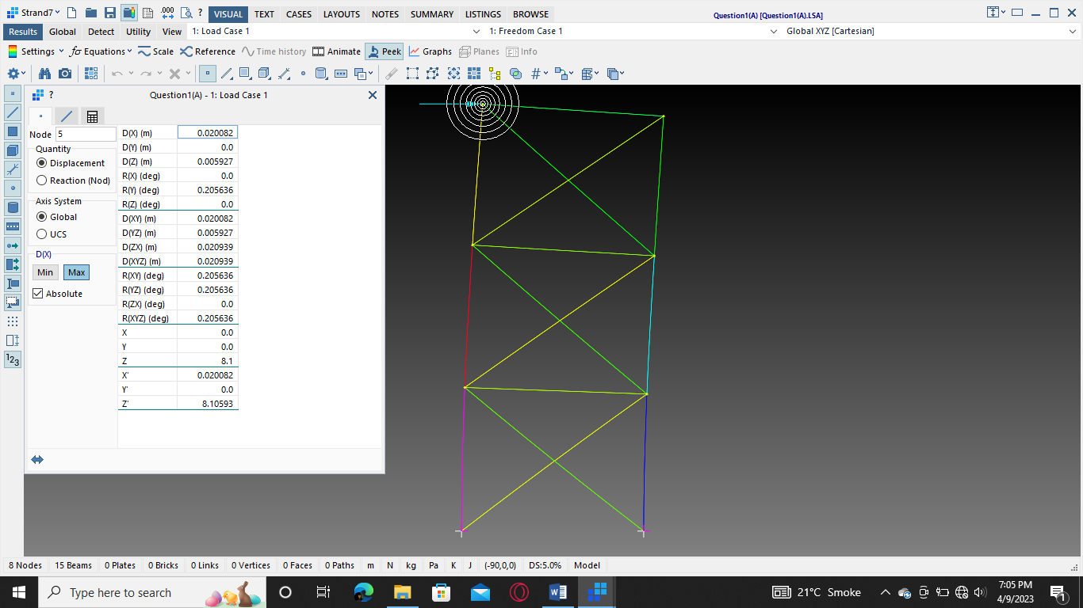Because the joints between the components of a rigid frame construction are intended to be rigid, meaning they are not permitted to spin or deflect under load, the displacement in a rigid frame (20 mm) is smaller than that in a plain truss (27 mm). As a result, the building is more stable and capable of withstanding lateral loads like wind and seismic pressures. The members of the frame, however, cannot significantly deform independently of one another since the joints are rigid. As a result, the entire frame deflects as a single unit when the frame is subjected to external stresses, causing bigger overall displacements than a simple truss.

Figure 5: Maximum Displacement in node as a rigid frame

A plain truss, on the other hand, is a construction made up of straight members joined together at joints, where the joints are made to be pin-connected and allow for rotation. Because each member may move individually, the truss can experience more significant deformations with less overall displacement. Truss systems are therefore often more effective than rigid frames at minimising deflection under load.

In conclusion, the different joint types and levels of permitted deformation at the joints are the main causes of the displacement discrepancy between rigid frames and plain trusses. As depicted in Figures 5 and 6,

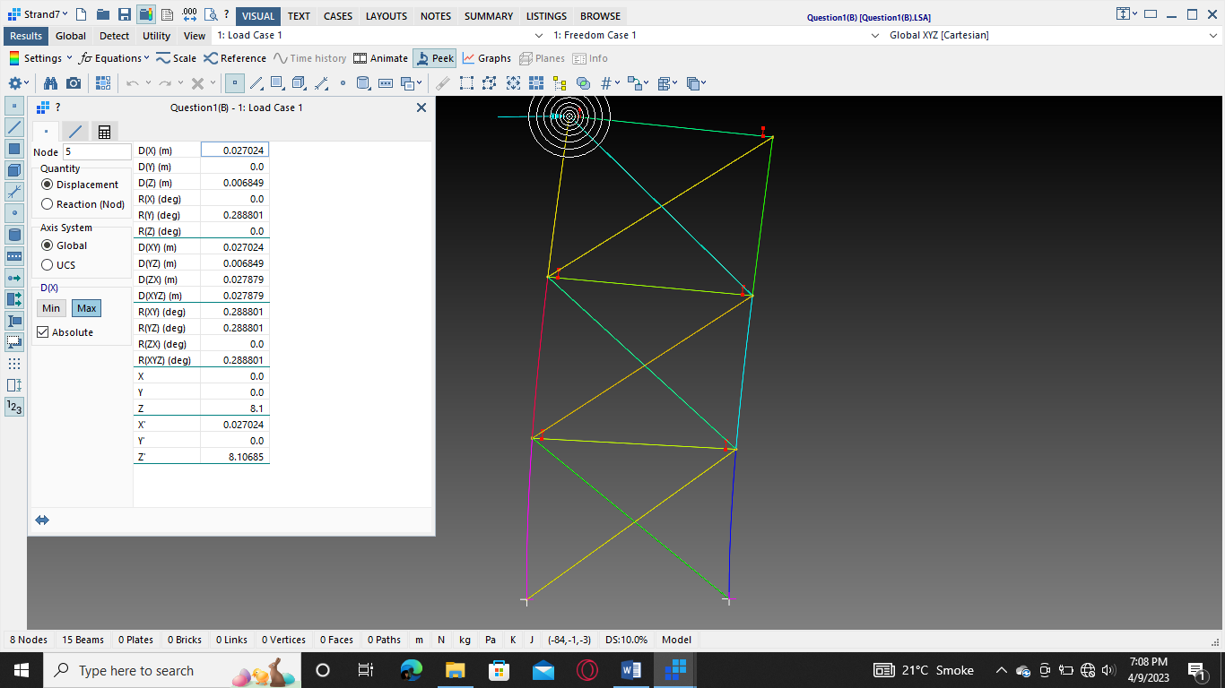

Figure 6:Maximum Displacement in node as a plane truss

### 1.4 Conclusion:

A truss structure's behaviour would not be correctly reflected by the study if it were modelled as a rigid frame. This could lead to a design that is unstable, hazardous, or inefficient. As a result, it's crucial to precisely model and assess a building using information on its real kind, construction, and shape.

It is a typical idealisation to believe that the truss members are hard in the plane of the structure but flexible outside of it when modelling a truss using frame elements. This indicates that the members are capable of withstanding axial stresses along their length but not moments of bending or twisting.

The following presumptions can be made while modelling a truss utilising frame components: :

* The truss's joints are stiff and non-rotating.
* The truss's members are parallel to one another and have a consistent cross-sectional area along their whole length.
* The members cannot withstand bending or twisting moments; they can only withstand axial forces along their length.
* Only the truss joints are used to apply external loads.

These presumptions allow for the idealisation of the truss utilising frame members with only axial stiffness and no bending or torsion stiffness. The joints of the truss can be used to apply external loads and connect the frame parts to represent the members.

By assuming that the members' bending and torsional stiffness are insignificant in comparison to their axial stiffness, the frame element can be utilised to mimic a truss. For trusses like roof trusses or bridge trusses, which are intended to carry axial loads in the majority, this is a realistic assumption. Engineers can streamline the analytical process and lower the amount of computer resources needed to address the issue by modelling the truss using frame elements.

# **Problem Statement no.2:**

**For the 1.5 m long tapered beam shown, the cross- section at node 1 is 50x50 mm and at node 2 is 20x20 mm. The elastic modulus is 25 GPa and density of the beam material is 2400 kg/m3 . Use Strand 7 to determine the elongation of the beam due to self-weight with one, two, five and ten 1-D elements. Plot the elongation profile for comparison and discuss the results. Also, plot the vertical stress variation along the beam and discuss the results.**

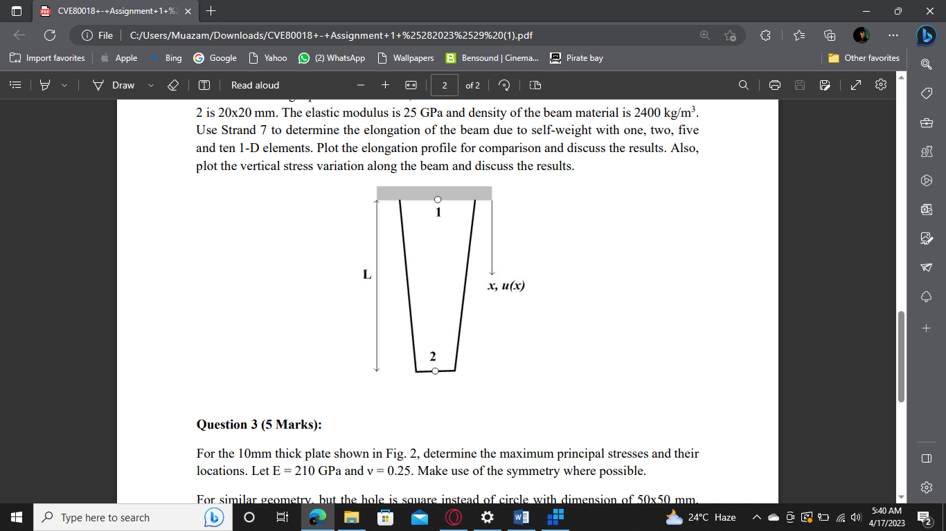

## Solution no. 2:

The displacement/elongation of the member decreases as we increase the number of its constituents, as seen in the attached figs. 7 to 10. Because breaking an element down into smaller sub-elements can help lower the displacement of the element, the displacement in 10-D element (5.4 x 1011) is less than that in 1-D element (6.4 x 1010). This is because the curvature of an element can be more accurately estimated when it is broken into smaller pieces, which can result in more accurate findings.

The number of nodes within an element increases when it is subdivided into smaller sub-elements, enabling a more realistic representation of the structure's deformation behaviour. This is because a more precise approximation of the real deformation can be produced by precisely interpolating the nodal displacements.

The element aspect ratio, which is the proportion of an element's length to its width, can also be decreased by subdividing an element into sub-elements. In areas with significant stress or strain gradients, elements with high aspect ratios can produce erroneous findings. The aspect ratio of each individual sub-element can be decreased by breaking the element up into smaller sub-elements, which can increase the accuracy of the results.

As a result of a more accurate depiction of the structure's deformation behaviour, a smaller element aspect ratio, and a more accurate approximation of the element's curvature, breaking an element into sub-elements can assist enhance the correctness of the findings of a finite element analysis.

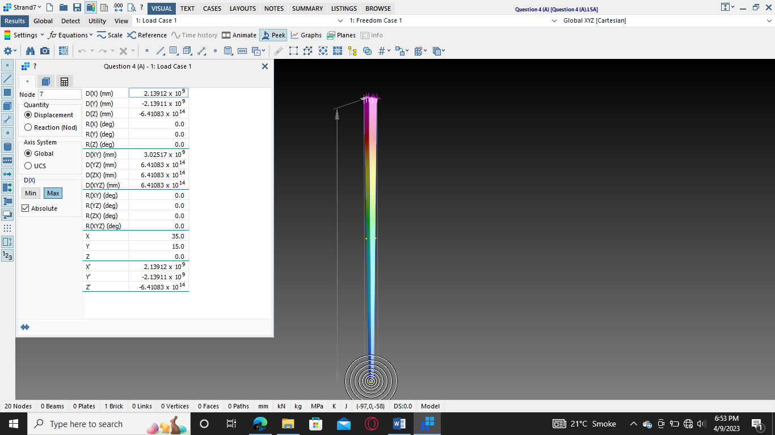

Figure 7: Elongation in 1-D element Beam

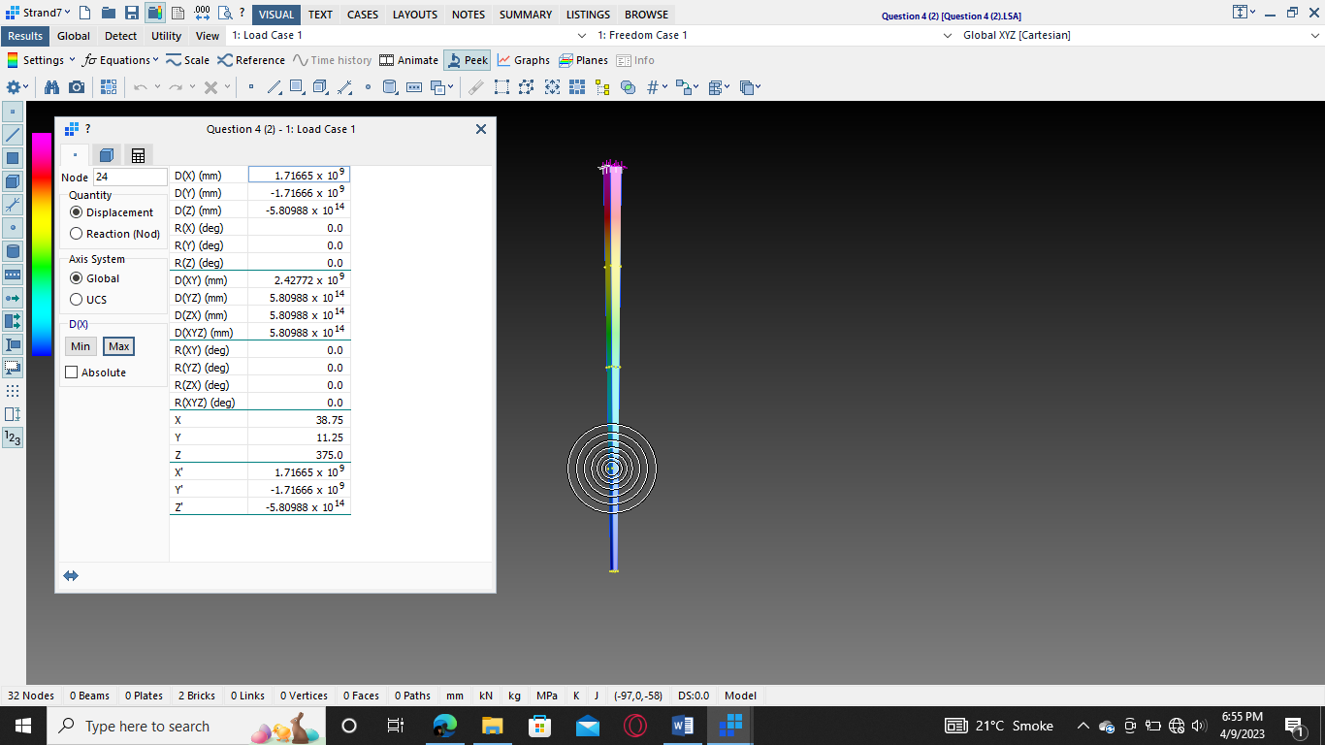

Figure 8: Elongation in 2-D element Beam

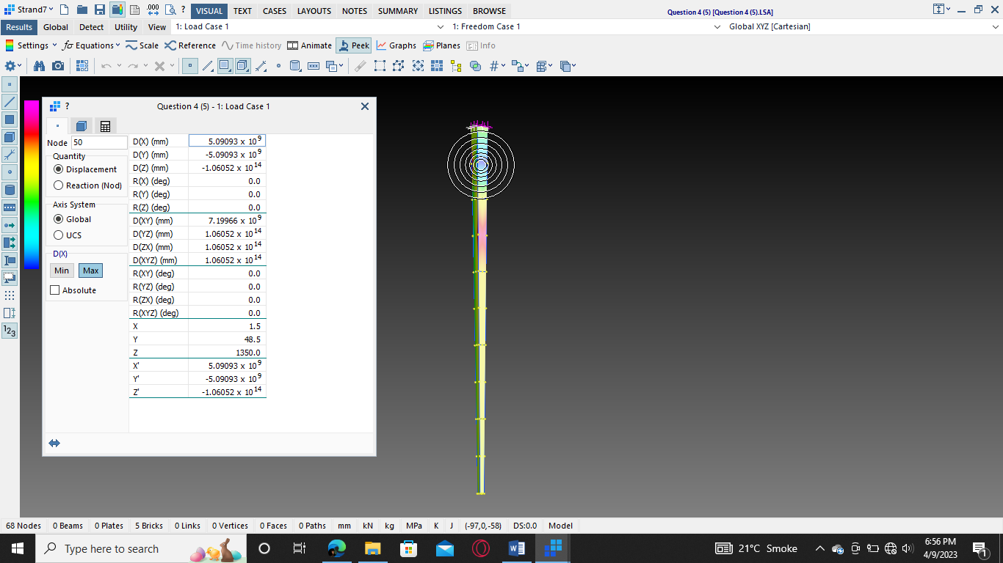

Figure 9: Elongation in 5-D element Beam

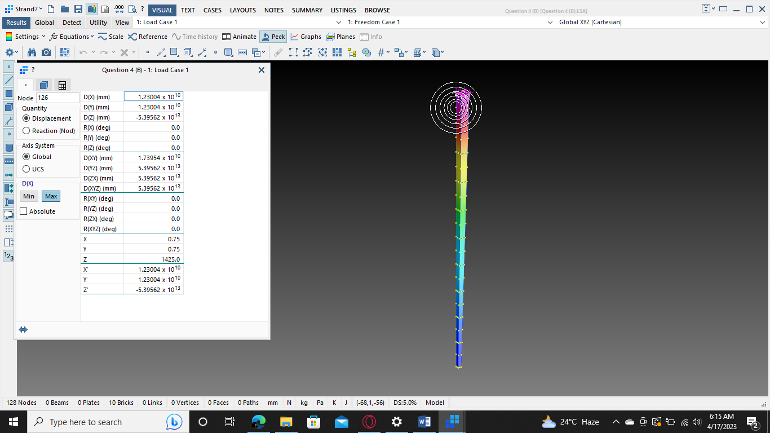

Figure 10: Elongation in 10-D element Beam

### 2.1 Stresses in Element

The stresses in the members are growing when we divide the element into additional sections, as seen in figs. 11 to 14. This is because breaking an element into smaller sub-elements can result in an increase in stresses. This is so that localised stress concentrations and gradients inside the element can be better captured by the smaller sub-elements.

When an element is divided into smaller sub-elements, the nodal stresses are interpolated over each sub-element. This interpolation can lead to higher stress values in certain areas, particularly in

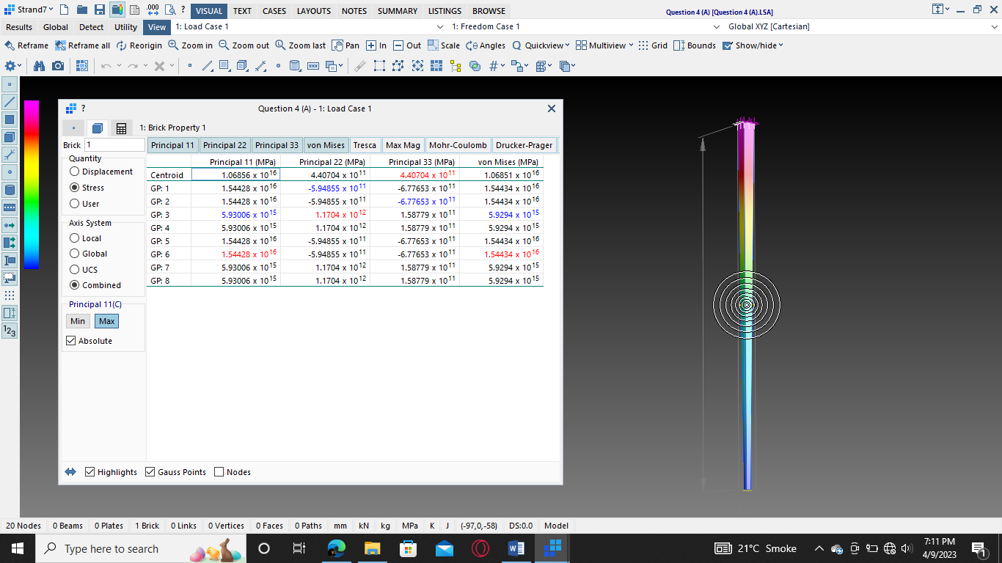

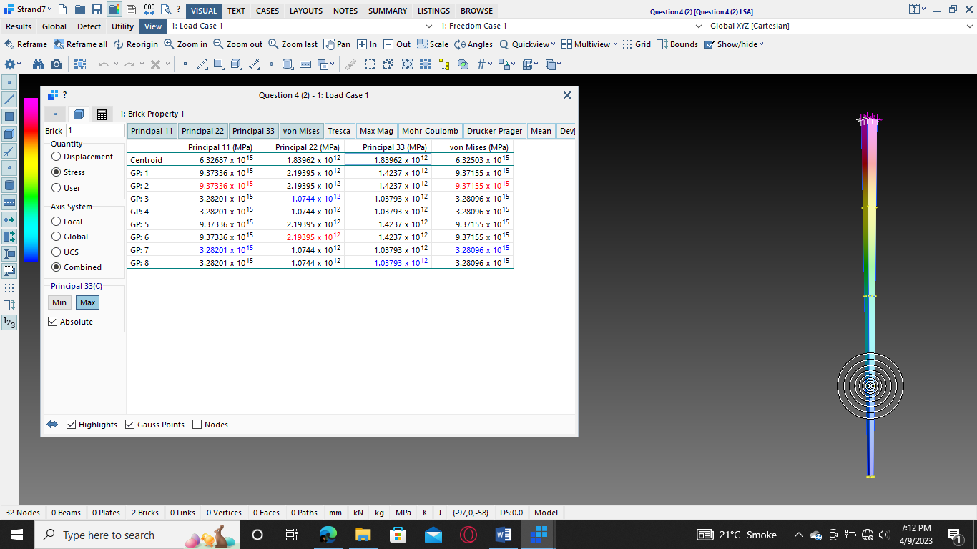Figure 11: Maximum Stresses in 1-D element

Figure 12: Maximum Stresses in 2-D element

regions where there are high stress gradients or stress concentrations. This is because the sub-elements can better capture the localized stress behavior that may be missed in larger elements.

Separating an element into smaller parts can also result in the introduction of new stress factors, such as shear stresses, which can increase the element's overall stress.

It is crucial to remember that the increased accuracy of the results of the finite element analysis more than makes up for the average slight increase in stress caused by element subdivision.

In conclusion, the introduction of more stress components and better localised stress behaviour capture can result in an increase in stresses when an element is divided into sub-elements. The advantages of greater precision in the analysis results outweigh the generally little increase in stress.

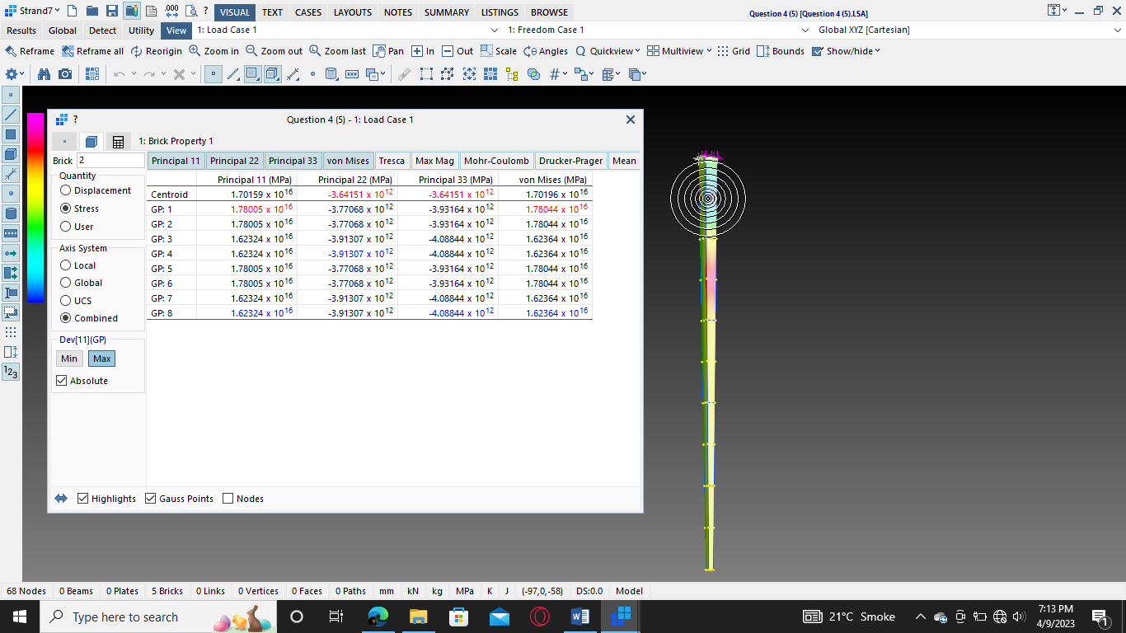

Figure 13: Maximum Stresses in 5-D element

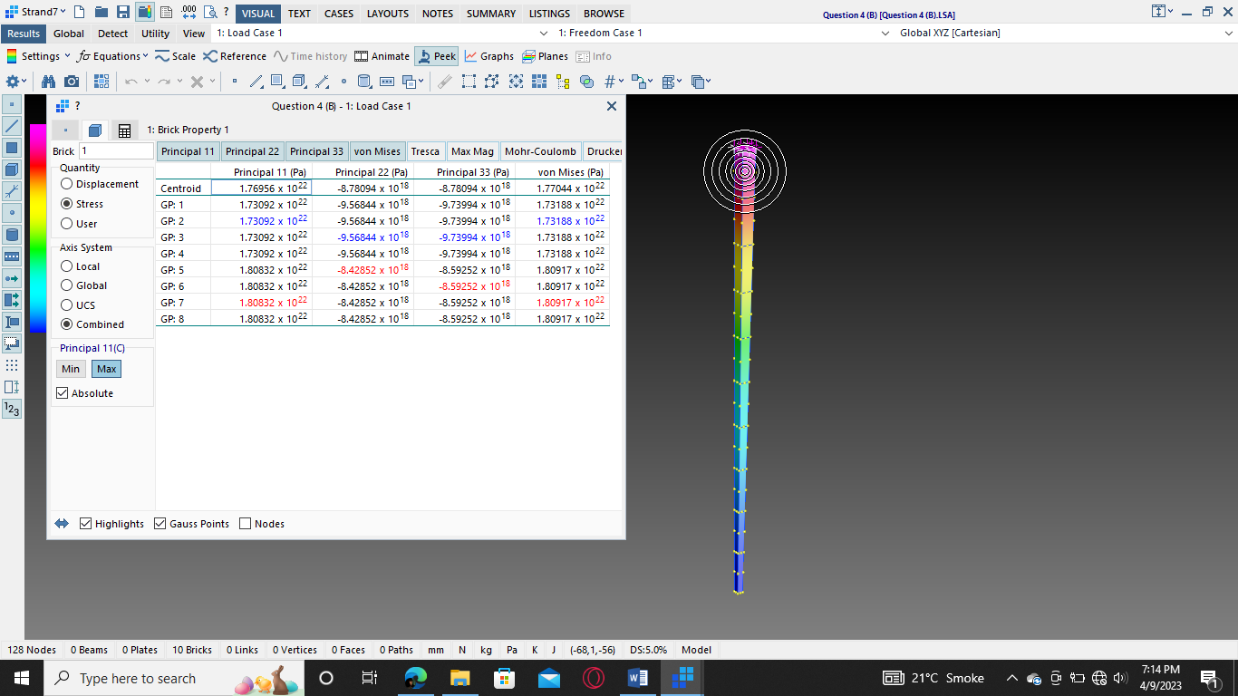

Figure 14: Maximum Stresses in 10-D element

# **Problem Statement no.3:**

**For the 10mm thick plate shown in Fig. 2, determine the maximum principal stresses and their locations. Let E = 210 GPa and ν = 0.25. Make use of the symmetry where possible. For similar geometry, but the hole is square instead of circle with dimension of 50x50 mm, determine the maximum principal stresses and their location. Compared and discussed the results between circular and rectangular holes.**

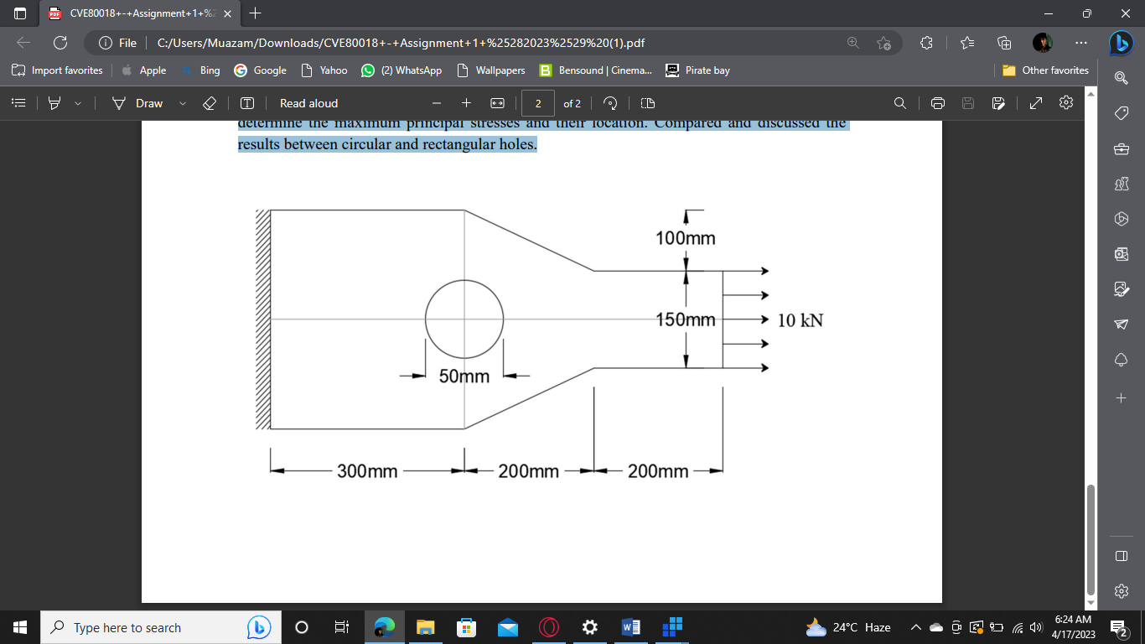

## Solution no. 3

The stress concentration increases when a square or circular cutout is made in a plate. But generally speaking, a circular cutting will provide less stress concentration than a square shape. This is due to the circular cutout's more symmetrical and uniform shape, which causes pressures to be distributed around the cutout more evenly.

When a square is cut out, the corners serve as stress concentrators, which makes the stress highly localised and concentrated around the corners. Higher stresses may arise in the area surrounding the square cutout, particularly in the corners, which may result in crack initiation or failure. A circular cutout, on the other hand, lacks any sharp edges and the tension is distributed more evenly throughout the cutout, leading to lower stress concentrations.

Additional stress concentration may result from the fact that the principal strains at the square cutout's corners are directed differently. The principle stresses, on the other hand, are more uniform and do not have any abrupt changes in direction around a circular cutting.

Because of this, there are typically more stresses concentrated around square cutouts than around circular ones, which results in higher principal stresses close to the cutout.

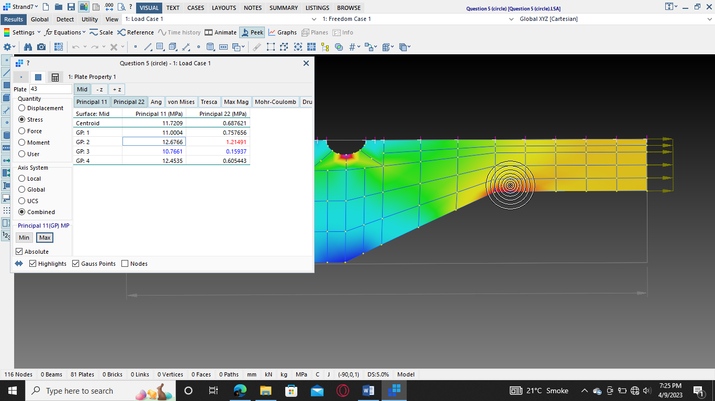

Figure : Principle stresses in a Metal Plate with a circular cutout

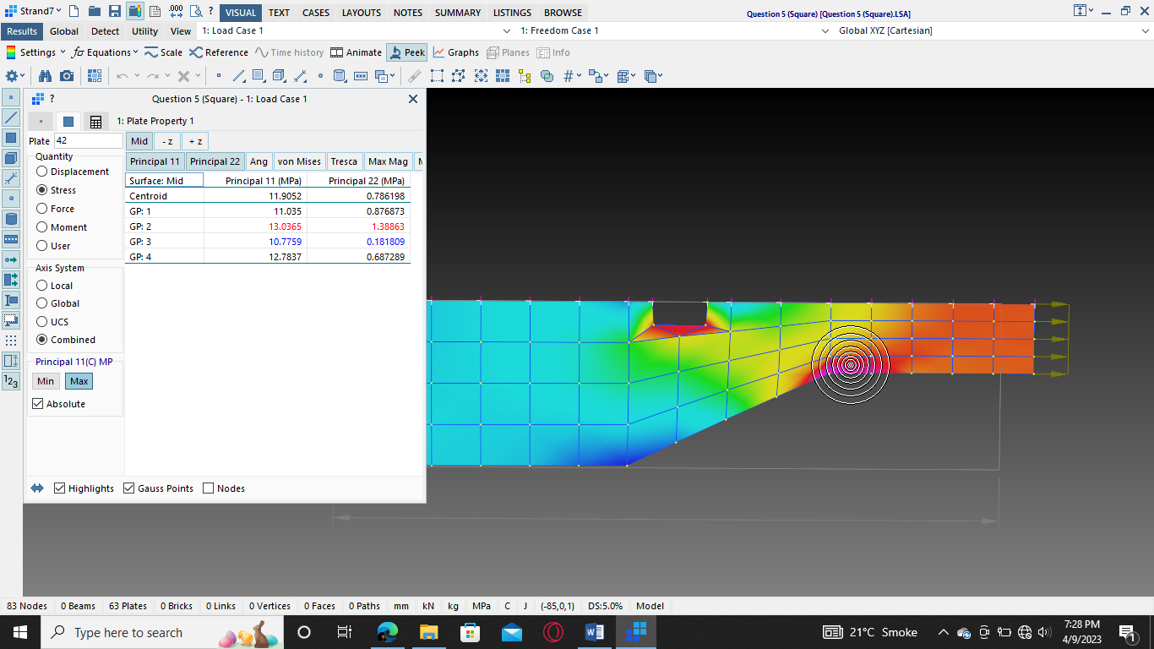

Figure : Principle stresses in a Metal Plate with a Rectangular cutout